Websites and useful information for children and young people

Respect Me  Web. www.respectme.org.uk | 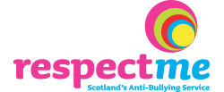
Childline  Web. www.childline.org.uk/explore/bullying/pages/bullying.aspx  ChildLine (at any time)  Tel. 0800 1111 - calls are free and confidential.  Web. www.childline.org.uk | 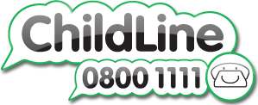
NSPCC helpline  For adults concerned about a child.  “If you're worried about a child, even if you're unsure, contact our professional counsellors 24/7 for help, advice and support.”  Tel. 0808 800 5000  Email. help@nspcc.org.uk  Web. www.nspcc.org.uk | 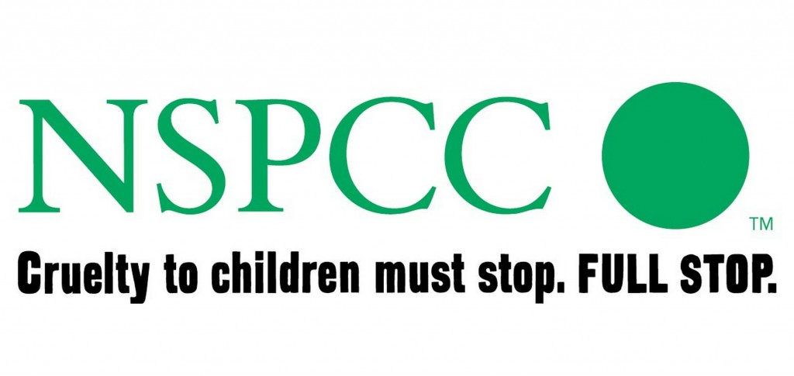
EACH  Homophobic Bullying  Tel. 0808 1000 143 Mon-Fri 9:00am-5:00pm (Helpline)  Web. www.eachaction.org.uk | 
Kidscape
Advice for young people
Web. https://www.kidscape.org.uk/advice/
advice-for-young-people/

Council for Disabled Children
Web. www.ncb.org.uk
Peer Support
See page 9 of the multi-agency anti-bullying framework for more ideas about how to resolve bullying.
Anyone you trust might be able to help you like a friend, a fellow pupil or work colleague, a teacher or manager, a union representative or employer.

