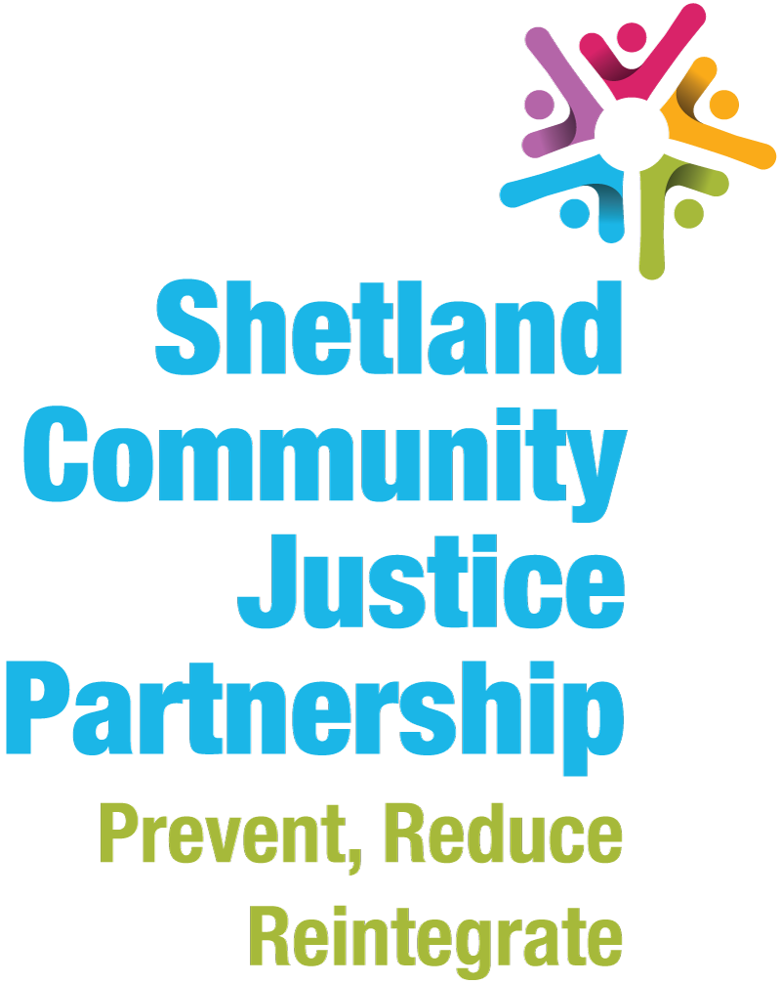

Annual Report 2018-19

Shetland Community Justice Partnership Annual Report 2018/19

Shetland Community Justice Partnership

Community Justice is about preventing and reducing further offending by addressing the underlying causes. It is where individuals, agencies and services work together to support, manage and supervise people with convictions or with a history of offending. It aims to reduce offending behaviour and the harm that offending causes, and promote social inclusion and citizenship.
Shetland Community Justice Partnership want to secure the best possible outcomes for people with convictions, victims and witnesses, families and communities. We want to safely and effectively manage and support those who have committed offences to help them reintegrate and realise their potential for the benefit of the whole community. We want to make sure that everyone affected by offending behaviour have access to the support they need to recover from the impact of crime.

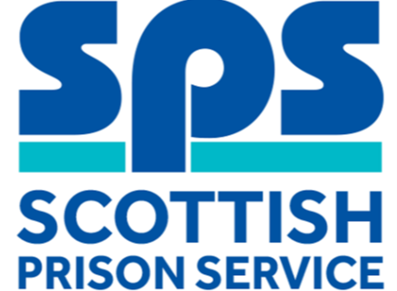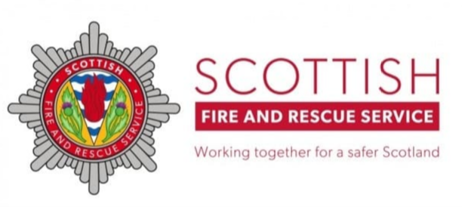

This annual report will outline they key activity of Shetland Community Justice Partnership during 2018/19, and next steps for 2019/20.

Community Justice Activity in Shetland 2018/19
The Scottish Government’s National Outcomes Performance and Improvement Framework details a series of structural and person-centred outcomes to achieve the vision contained within the National Strategy for Community Justice.
Local improvement actions have been identified to support achievement of these national outcomes. Planning and delivery of community justice in Shetland is based around 3 priority themes contained within the Shetland Community Justice Plan to deliver these local actions, which in turn deliver on the Scottish Government national outcomes for community justice.
Local Priority Themes

Key activity and information during 2018/19 in relation to structural and person-centric outcomes is outlined below.
National Structural Outcomes
Communities improve their understanding and participation in Community Justice | Partners plan and deliver services in a more strategic and collaborative way | People have better access to the services that they require, including welfare, health and wellbeing, housing and employability | Effective Interventions are delivered to prevent and reduce the risk of further offending

- ‘Unpacking a Restorative Shetland’ event, hosted by Space2face and Relationships Scotland was again supported by SCJP. The day-long seminar is the sixth in the series and this year explored restorative approaches to gender based violence, the bystander approach and restorative communities.

- Joint delivery of individual support work undertaken by Criminal Justice Social Work with local churches, with church volunteers acting in a safeguarding role.

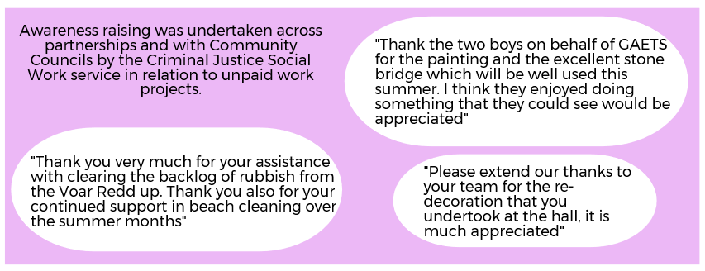
- Level of community awareness of/satisfaction with work undertaken as part of a CPO was 100%.

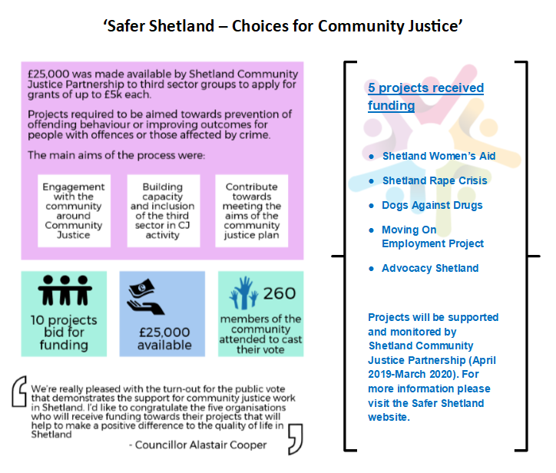

- New Healthy Shetland Health Check tool is in final stages of development. Planning is underway for health check being offered as standard for all CJSW clients. | - Work with Families Outside, not only to provide support to families affected by imprisonment, but to be a voice for Shetland at a national level in relation to issues such as remote prison visits, assisted prison visits, and travel issues for prisoners’ families.
- Asset Based Community Development workshops, organised jointly by Health & Social Care and Community Planning & Development, run in January 2019. The workshops looked at the relationship between organisations and communities, how these are changing, and how this change is going to require a fundamental shift in behaviour from both officers in organisations and residents in communities. Attendance was offered across Community Planning Partnership agencies and attended by staff working within community justice | - The emotional wellbeing and resilience project currently underway in Shetland aims to develop: a whole system approach to emotional wellbeing to benefit all children, improved equality of opportunity and outcomes for vulnerable children, sustainable support for children whose emotional resilience s at risk, proactive and preventative approaches to emotional resilience, improved capacity of mental health resources to manage mental health needs, and a collective, Shetland-wide strategy for emotional wellbeing and resilience.  The outcomes are closely linked to actions and outcomes contained within the Community Justice Plan, and this project clearly addressed some of the root causes of offending behaviour.

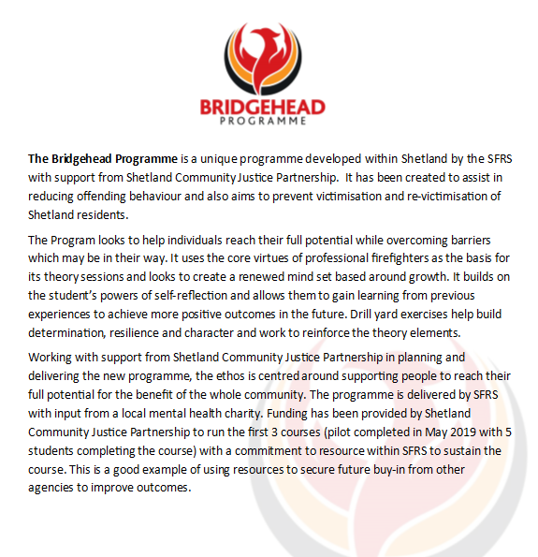

- Understanding dental pathways was an obstacle to oral hygiene and this was discussed between partners and the dental service. Fast track access to dental services has been put in place in order to prevent lengthy delays with referrals being accepted from Justice Social Workers. | - Funding has been provided by Shetland Community Justice Partnership for sessions at Clickimin for CJSW clients – a really valued service which improves the health and wellbeing of clients for whom access to recreational activities would not be affordable. Looked after Children and Care Leavers continue to have free access to recreational activities in Shetland.
- Employability services in Shetland are managed by Shetland Islands Council, working with a wide range of participants to engage them in work related activities, learning, training and experience, work placements and work based training. ‘No one left behind’ sets out that there should be an emphasis on employability and justice, and cross-cutting policies are being developed by the Scottish Government relating to reintegrating people leaving prison, and improving opportunities for people with convictions. | - A multi-agency group to review ‘community reintegration on leaving custody’ met in relation to: throughcare support from custody to community, the availability of time critical services, and the uptake of those services. The group reported that joint-working arrangements and processes to ensure access to services which are currently in place work well.  100% of individuals who accessed throughcare services were assisted, as required, to obtain accommodation, access benefits, and register with a GP.  Weekly reports are received by SIC Housing and Criminal Justice Social Work in relation to admissions and liberations to/from custody to assist improvement in community justice outcomes.
- The ANCHOR project is a multi-agency programme designed to enable vulnerable families in Shetland to thrive, and participate in Shetland’s great quality of life. Anchor has been established in order to invest in understanding how to shift the resources we have towards early intervention; thereby reducing the intervention required as a result of statutory processes. It aims to bring about positive changes in the lives of families in Shetland who are struggling, whilst also gathering relevant information in order to change service delivery in the future, assisting other families in the longer-term. The project sponsor is the Area Commander for Police Scotland, other partners include the Council, Integrated Joint Board, NHS Shetland, Relationships Scotland – Shetland, Shetland Women’s Aid and Voluntary Action Shetland.

- The Voices for Equity project is about reducing inequalities in Shetland by establishing mutual learning relationships between people with lived experience of inequalities and people responsible for decisions in Shetland. Through the participants’ real life stories, the project delivers authentic narratives of experience of inequalities in Shetland.

National Person-Centric Outcomes
Life chances are improved through needs, including health, financial inclusion, housing and safety, being addressed | People develop positive relationships and more opportunities to participate through education, employment and leisure activities | Individual’s resilience and capacity for change and self-management are enhanced

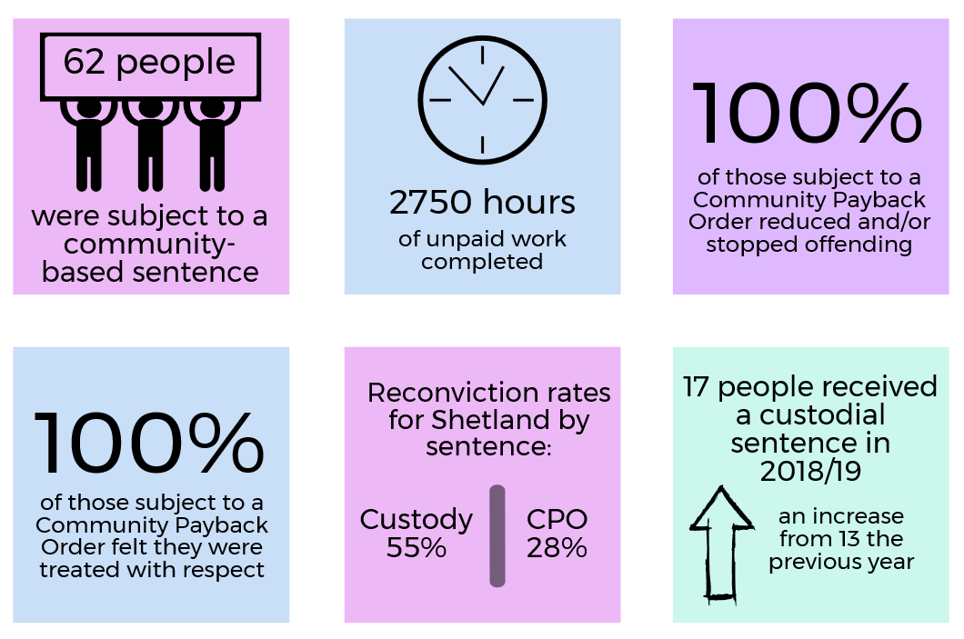

- All individuals who are subject to unpaid work are encouraged to make use of ‘other activities requirement’ in Community Payback Order. Individuals are encouraged to use other activities for personal development. Activities have included:

Mind your head – mental health awareness sessions, Skills Centre, Shetland College – further education information days, Adult Learning, Benefits sessions, Employability pathway, CSCS training.

- The Substance Misuse Recovery Service now have an open access system, where self-referrals are accepted. A needs assessment highlighted the need for wider engagement opportunities lower level support services are being explored as well as ways to have meaningful conversations around drug and alcohol use in settings such as Criminal Justice.

As part of the Alcohol Brief Interventions Improvement plan, Health Improvement Practitioners will be offering supported self-help, helping people access and work through materials around changing drinking habits. This may be all the help that is needed, or could be a more accessible/less daunting step towards SMRS.

Areas of improvement are measured by Criminal Justice Social Work for their clients in areas noted below, with some examples of comments from clients:

Housing “now have tenancy in new flat”
Employment/Training/Education “back at work”
Drugs “take less”
Alcohol “drinking less than I did a year ago, due to support and knowing I could do better”
Physical Health “much better”
Finances “a lot better at budgeting”
Mental Health “I am currently in a good frame of mind and have been for 6 months”

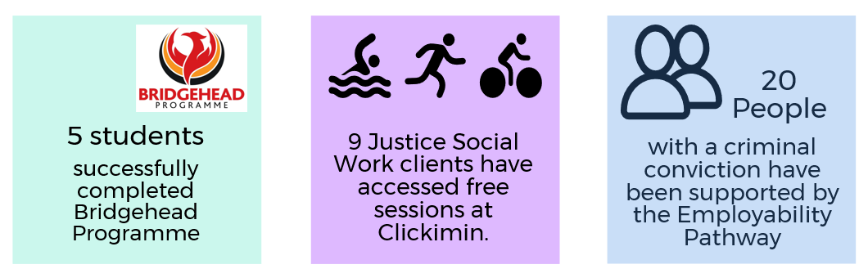

Next steps
Shetland Community Justice Partnership is undertaking a process of Self-Evaluation in 2019/20 with support from the Care Inspectorate. This process will lead to a number of areas of development which, alongside continued efforts to achieve local and national outcomes for community justice, will become a focus of partnership activity in the next 12 months.
A new Community Justice Plan will also be published in 2020, to continue to improve outcomes for everyone affected by offending behaviour in Shetland.

For more information about community justice in Shetland please visit: https://www.safershetland.com/community-justice

